**Programming Fundamentals**

**Lab Manual**

**Lab 04**



**Topic: File Handling & Functions**

**Faculty of Information Technology**

**UCP Lahore Pakistan**

**Q1:** Write a C++ program which takes an integer from user as input. Write the integer value from console to a text file named “file.txt” after user input.

**Q2:** Write a program that reads 3 integers from a file input.txt and writes the largest of the 3 numbers in another file output.txt.

**Example:**

Input.txt: 13 20 11

Ouptu.txt: 20

**Q3:** Write a C++ program which reads a file input.txt and counts and displays the number of alphabets in it.

**Example:**

Input1.txt: good day sir

Output: number of alphabets: 10

**Q4:** Write a C++ program that reads first name and last name from two txt files, input1.txt and input2.txt respectively and stores them in two separate arrays. Then merges these two arrays into another txt file output.txt.

**Example:**

Intput1.txt: Allie

Input2.txt: Miller

Output.txt: Allie Miller

**Q5:** Write a C++ program which takes ID, Name, GPA from user and save it in ‘file.txt’. Make a menu:

* Press 1 for Enter new record,
* Press 2 for Update the record,
* Press 3 for Exit.

The new record can be save into ‘file.txt’. For updating any record in ‘file.txt’, save the previous record in ‘temp.txt’.

**Example:**

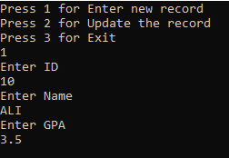

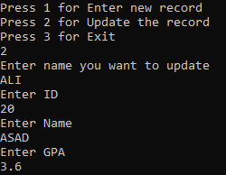

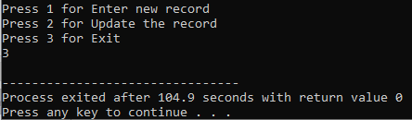

**Q6:** Write a C++ program that takes an integer number from user and display that number using print() function.

\***(Copy and run the program and check how function call works)**

**Code:**

#include <iostream>

using namespace std;

void print(int i); //Function Prototype

int main()

{

int marks = 0;

cout << "Enter a number\n";

cin >> marks;

print(marks); //Function Call

return 0;

}

void print(int i) //Function Definition

{

int y = i;

cout << "You entered " << y << endl;

}

**Q7:** Write a C++ program that perform following tasks:

1. Takes 2 integers from user and calculate the sum.
2. Now Calculate the sum using function Sum()

**Code:**

#include<iostream>

using namespace std;

void sum(); //Function Prototype

int main()

{

sum(); //Function call

return 0;

}

void sum() //Function definition

{

int num1, num2; //Declaring two integer variables

cout<<"Enter first integer number: ";

cin>>num1;

cout<<"Enter second integer number: ";

cin>>num2;

cout<<"Sum of entered numbers is: "<<(num1+num2); }

**Q8:** Write a C++ program that display marks of the students by array using functions.

\***(Copy and run the program and check how function call works)**

**Code:**

#include <iostream>

using namespace std;

void display(int marks[5]); //Function Prototype

//take an array as parameter

int main() {

int marks[5] = {77, 83, 55, 94, 68}; //Declare and initialize an array

//Pass an array as argument

display(marks); //Call display function return 0;

}

void display(int marks[5]) //Function Definition

{

cout << "Displaying marks: " << endl;

for (int i = 0; i < 5; ++i) //Display array elements

{

cout << "Student " << i + 1 << ": " << marks[i] << endl;

}

}